Aurora Role Population Investigation

# User Access Levels

A users access levels are populated just after passing a login check in the Application.cfm file. Where a hard-coded query titled "userInformation" selects all rows from the view, v_people_access , but checking if the employee id variable matches.

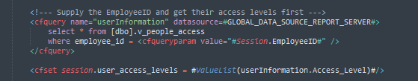

1 Lines 618 – 623

# Rightslist & Roles

The rightslist and roles values in the Session variable are not modified in any way and are left as empty strings.

# College & Department Access

There are two further sets of access settings for Aurora under the categories of College and Department

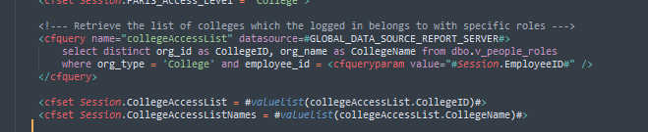

2 Lines 667 - 673

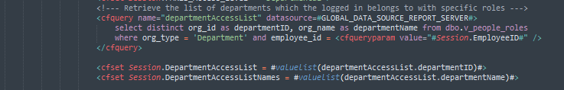

3 Lines 693 - 700

# ResearchID Access List

Research ID access list is a list of ResearchID’s the user can access in Aurora, this makes use of the most number of queries and views.

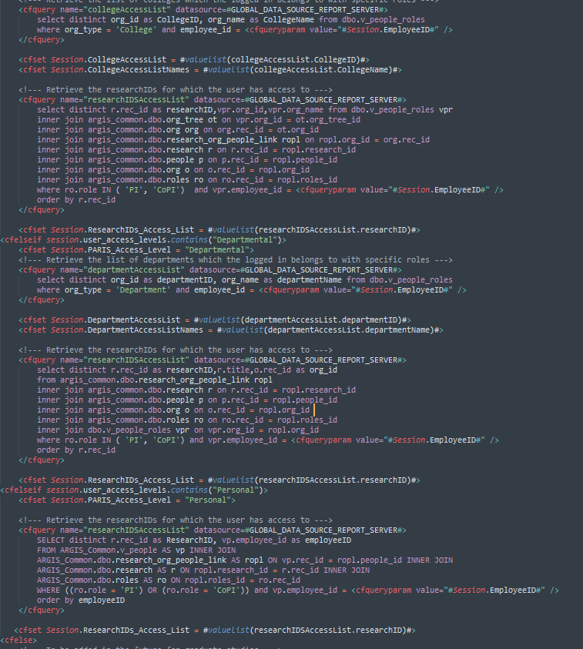

4 Lines 676 – 729

# Report Types

While not directly connected with user roles, a query containing Report types are used on page loads that are then compared to the users to determine if they are allowed to access the page.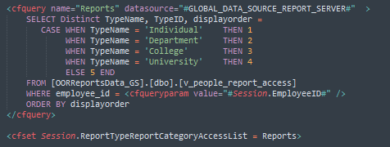

5 Lines 632 - 644

# Views and Stored Procedures

Among all of these queries, these are the main views that are present for gather roles/rights/access levels (At the moment there is no stored procedures as all of the queries are hard-coded):

|  |  |
| --- | --- |
| View | Description |
| v_people_roles | collegeAccessList (list of colleges which the logged in belongs to with specific roles) |
| v_people_access | userInformation (gathers user's Access Levels) |
| v_people_report_access | Gathers all the report types. |
| t_AuroraLog | Used to login session information when user logs in and out of Aurora |
| v_people_roles | Used to acquire ResearchID Access list |
| argis_common.dbo.research_org_people_link | “ |
| ARGIS_Common.v_people | “ |